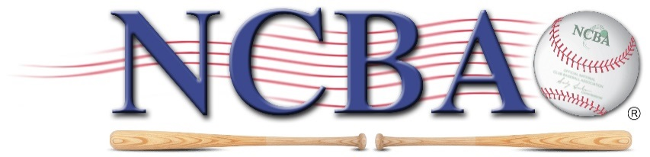
NCBA
850 Ridge Avenue
Suite 301
Pittsburgh, PA 15212
www.clubbaseball.org

REGISTRATION FORM
(Please e-mail to Eric.Curitore@CollClubSports.com)

NAME OF INSTITUTION:

CLUB/REC SPORTS OFFICE:

Address Line 1:
Address Line 2:
Address Line 3:

Club/Rec Sports
Director Name:

Phone Number:

Email Address:

PRIMARY REPRESENTATIVE:

Name:
Position:

Cell Phone Number:
Personal Email Address:
Team Email Address (If Applicable):

ALTERNATE REPRESENTATIVE:

Name:
Position:

Cell Phone Number:
Email Address:

HEAD COACH (If Applicable):

Name:

Cell Phone Number:
Email Address:

TEAM WEBSITE (If Applicable):

